# PROJECT NAME: BUILDING A BLOG APP

**TEAM ID:** LTVIP2023TMID05394

**TEAM SIZE:** 5

**TEAM LEADER:** KOMMASANI.MAHESH REDDY

**TEAM MEMBERS:**

1. GARIKAPATI.SAITEJA

2. GRANDHI.VENKATESH

3. JAYA PRAKASHSUDA

4. KONAKANCHI.ABHINASH

# INDEX

## 1.INTRODUCTION

1.1 Overview of building a blog app.

1.2 Purpose of building a blog app.

## 2.LITERATURE SURVEY

2.1 Existing problem in building a blog app

2.2 Proposed solution in building a blog app

## 3.THEORITICAL ANALYSIS

3.1 Block diagram of building a blog app.

3.2 Software designing of building a blog app.

**4. RESULT**

**5.ADVANTAGES & DISADVANTAGES**

**6. APPLICATIONS**

**7. CONCLUSION**

**8. FUTURE SCOPE**

# 1. INTRODUCTION

**1.1 Overview of building a blog app**

Building a blog app in front-end web development involves creating a user interface that allows users to view, create, and interact with blog posts. Here's a general overview of the steps involved:

**1.Planning and Design:**

Define the requirements and features of your blog app.

Create wireframes and mockups to visualize the layout and design of the app.

**2.Setting Up the Project:**

Choose a front-end development stack: HTML, CSS, and JavaScript are fundamental, and you may use frameworks like React, Angular, or Vue.js for more complex apps.

Set up your development environment and install any necessary tools.

**3.Creating the Basic Structure:**

Start by creating the main HTML file and include the necessary CSS and JavaScript files.

Build a responsive layout with a header, footer, navigation, and main content area.

**4.Implementing Routing:**

If using a front-end framework that supports routing, set up routes for different views (e.g., home page, individual blog post page, etc.).

**5.Fetching Blog Data:**

Connect your app to a backend API to fetch blog posts and relevant data. Alternatively, you can use mock data during development.

**6.Displaying Blog Posts:**

Use JavaScript to fetch blog posts from the API and dynamically render them on the frontend.

Create components for displaying individual blog posts in a list.

**7.Viewing Individual Blog Post:**

Set up a route and a corresponding component to display individual blog posts.

Fetch the specific blog post data based on the selected post.

**8.Adding Interactivity:**

Implement features like comments, likes, and sharing options for blog posts.

Add features that enhance user experience, such as pagination or infinite scrolling.

**1.2 Purpose of building a blog app**

The purpose of building a blog app can vary depending on the specific goals and needs of the developer or organization creating it. Some common purposes for building a blog app include:

**1.Content sharing and publishing:** A blog app provides a platform for individuals or businesses to share their thoughts, ideas, expertise, and knowledge with a wider audience.

**2.Personal branding:** For individuals, a blog app can be a powerful tool for personal branding and establishing themselves as thought leaders or experts in their respective fields. It can help in building a reputation and credibility within a particular industry.

**3.Marketing and promotion:** Businesses often use blog apps as part of their content marketing strategy. By regularly publishing valuable and relevant content, they can attract and engage their target audience and potentially convert readers into customers.

**4.Community engagement:** A blog app can foster a community around a particular topic or niche. It allows readers to interact with the author through comments, discussions, and social sharing and community around the content.

**5.Monetization:** Blog apps can be monetized through various means, such as displaying ads, sponsored content, affiliate marketing, or by selling digital products, courses, or services related to the blog's content.

**6.Portfolio showcase:** For writers, designers, photographers, and other creatives, a blog app can serve as a showcase of their work and skills.

**7.Knowledge repository:** Blogs can serve as a repository of knowledge, where individuals or organizations can document their learnings, experiences, and insights.

**8.Learning and education:** educational institutions or e-learning platforms can use blog apps to provide supplementary materials, study guides, or resources for their students. It can also be used as a space for instructors to share updates and engage with learners.

Overall, the purpose of a blog app is to facilitate content creation, distribution, and interaction in a user-friendly and accessible manner, enabling the achievement of various goals depending on the intentions of its creators.

## 2.LITERATURE SURVEY

**2.1 Existing problem**

Building a blog app can come with several challenges and potential problems. Some of the common issues developers may encounter include:

**1.Content management:** Developing an efficient content management system (CMS) that allows users to easily create, edit, and organize their blog posts can be complex. Ensuring that the CMS is user-friendly, yet robust enough to handle various content types and formats can be a challenge.

**2.Security vulnerabilities:** Blogs are susceptible to various security risks, such as SQL injection, cross-site scripting (XSS), and data breaches. Implementing strong security measures and regularly updating the app to protect against emerging threats is crucial.

**3.Performance and scalability:** As the blog app gains traction and attracts more users, its performance and scalability may become issues. Ensuring that the app can handle increasing traffic and content without compromising speed and responsiveness is essential.

**4.User engagement and interaction:** Encouraging user engagement through comments, likes, shares, and social media integration can be challenging. Creating an interactive and dynamic user experience that fosters a sense of community can be a hurdle.

**5.Mobile responsiveness:** With a significant portion of internet traffic coming from mobile devices, optimizing the blog app for various screen sizes and devices is vital. Building a responsive design that provides a seamless experience across different platforms can be tricky.

**6.Search engine optimization (SEO):** Making the blog app SEO-friendly to improve its visibility on search engines requires careful planning and implementation of SEO best practices**.**

**7.Content moderation:** Dealing with spam, inappropriate content, or offensive comments can be a concern.

**8.Data backup and recovery:** Ensuring that user data and blog content are regularly backed up and can be restored in case of data loss or system failures is crucial for the long-term success of the app.

Successfully addressing these challenges and problems requires careful planning, thorough testing, and continuous improvement based on user feedback and evolving industry best practices.

### 2.2 Proposed solution

To build a successful blog app, it's important to consider the following proposed solutions:

**1.User-friendly CMS:** Develop an intuitive and user-friendly content management system

(CMS) that allows bloggers to easily create, edit, and organize their posts. Provide a clean and straightforward user interface with WYSIWYG (What You See Is What You Get) editor for seamless content creation.

**2.Security measures:** Implement robust security measures to protect user data and the app from potential threats. Use encryption for sensitive information, conduct regular security audits, and keep software and plugins up to date to address vulnerabilities.

**3.Performance optimization:** Optimize the blog app for speed and scalability. Use caching mechanisms, Content Delivery Networks (CDNs), and server-side optimizations to ensure quick loading times, especially for media-heavy content.

**4.Engaging features:** Incorporate features that encourage user engagement and interaction. This could include a commenting system, social media sharing buttons, email subscriptions, and a user-friendly notification system for updates.

**5.Mobile responsiveness:** Ensure the blog app is fully responsive and provides an excellent user experience across various devices and screen sizes.

**6.SEO-friendly architecture:** Design the app with SEO best practices in mind. Optimize URLs, implement proper heading structures, allow customizable meta tags, and enable schema markup to improve search engine visibility.

**7.Content moderation:** Implement effective content moderation tools to prevent spam and maintain a positive user experience. Use CAPTCHA, comment flagging, and automated filters to identify and remove inappropriate content.

**8.Data backup and recovery:** Set up regular backups of user data and content to avoid data loss in case of any unforeseen events. Provide a way for users to export their data if they wish to switch platforms.

Remember that the success of a blog app relies on continuous improvement, listening to user feedback, and staying updated with the latest trends in blogging and web development.

## 3.THEORITICAL ANALYSIS

**3.1 Block diagram**

The blog app is a web application that provides real-time blog posts. Based on products, Solutions, New technologies, New projects, and Management. The blog app is fully responsive. The blog is made using Java script, CSS, HTML,and Bootstraps. The central theme of the blog is to show new ideas and new innovations on the website

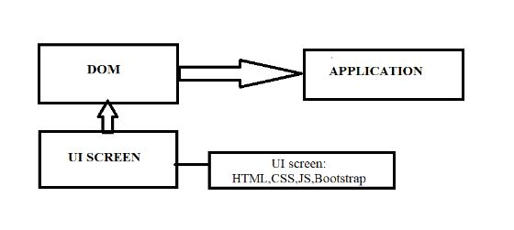

**3.2 Software designing of building a blog app.**

**Prerequisites:**

Before you begin building the Blog App, ensure you have the following:

- A code editor (e.g., Visual Studio Code, Sublime Text, Atom)

- A web browser

- An internet connection

- Knowledge of HTML, CSS (or a CSS framework like Bootstrap), and JavaScript

## 4.RESULT

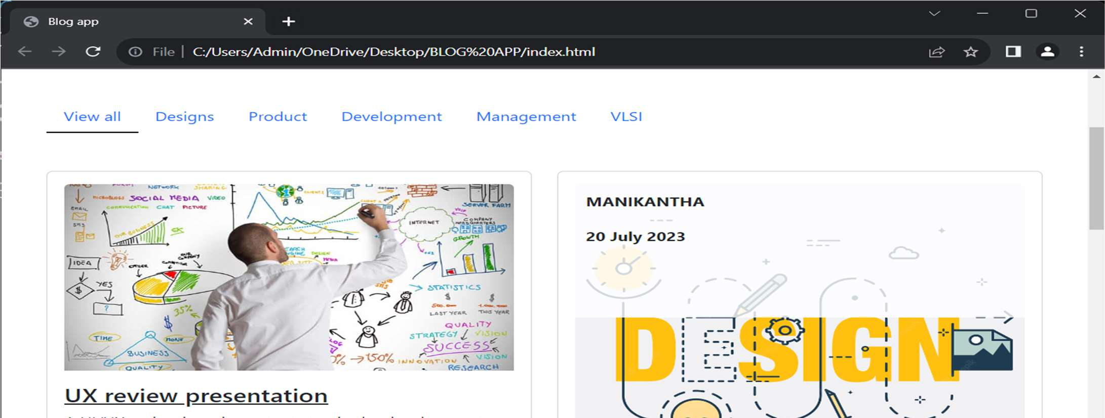

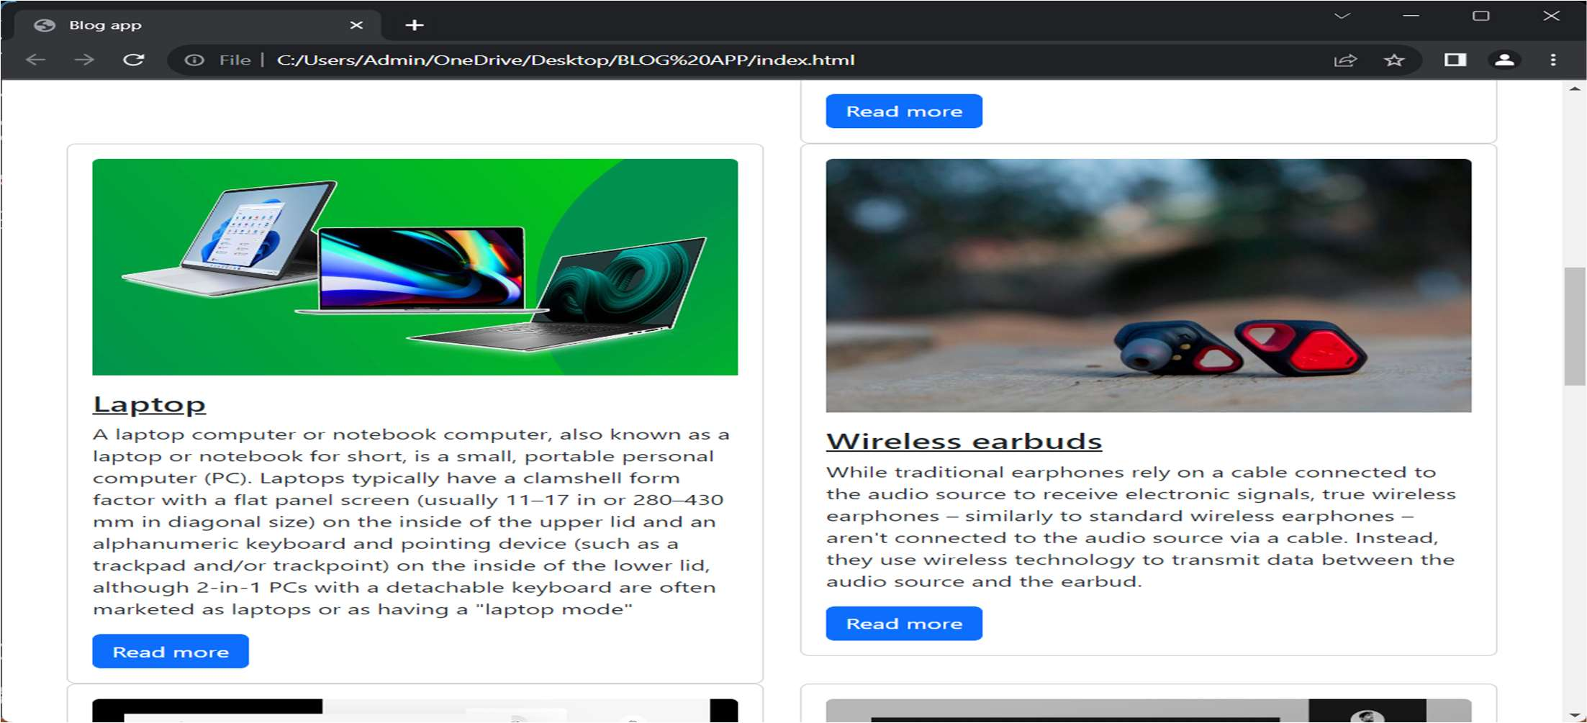

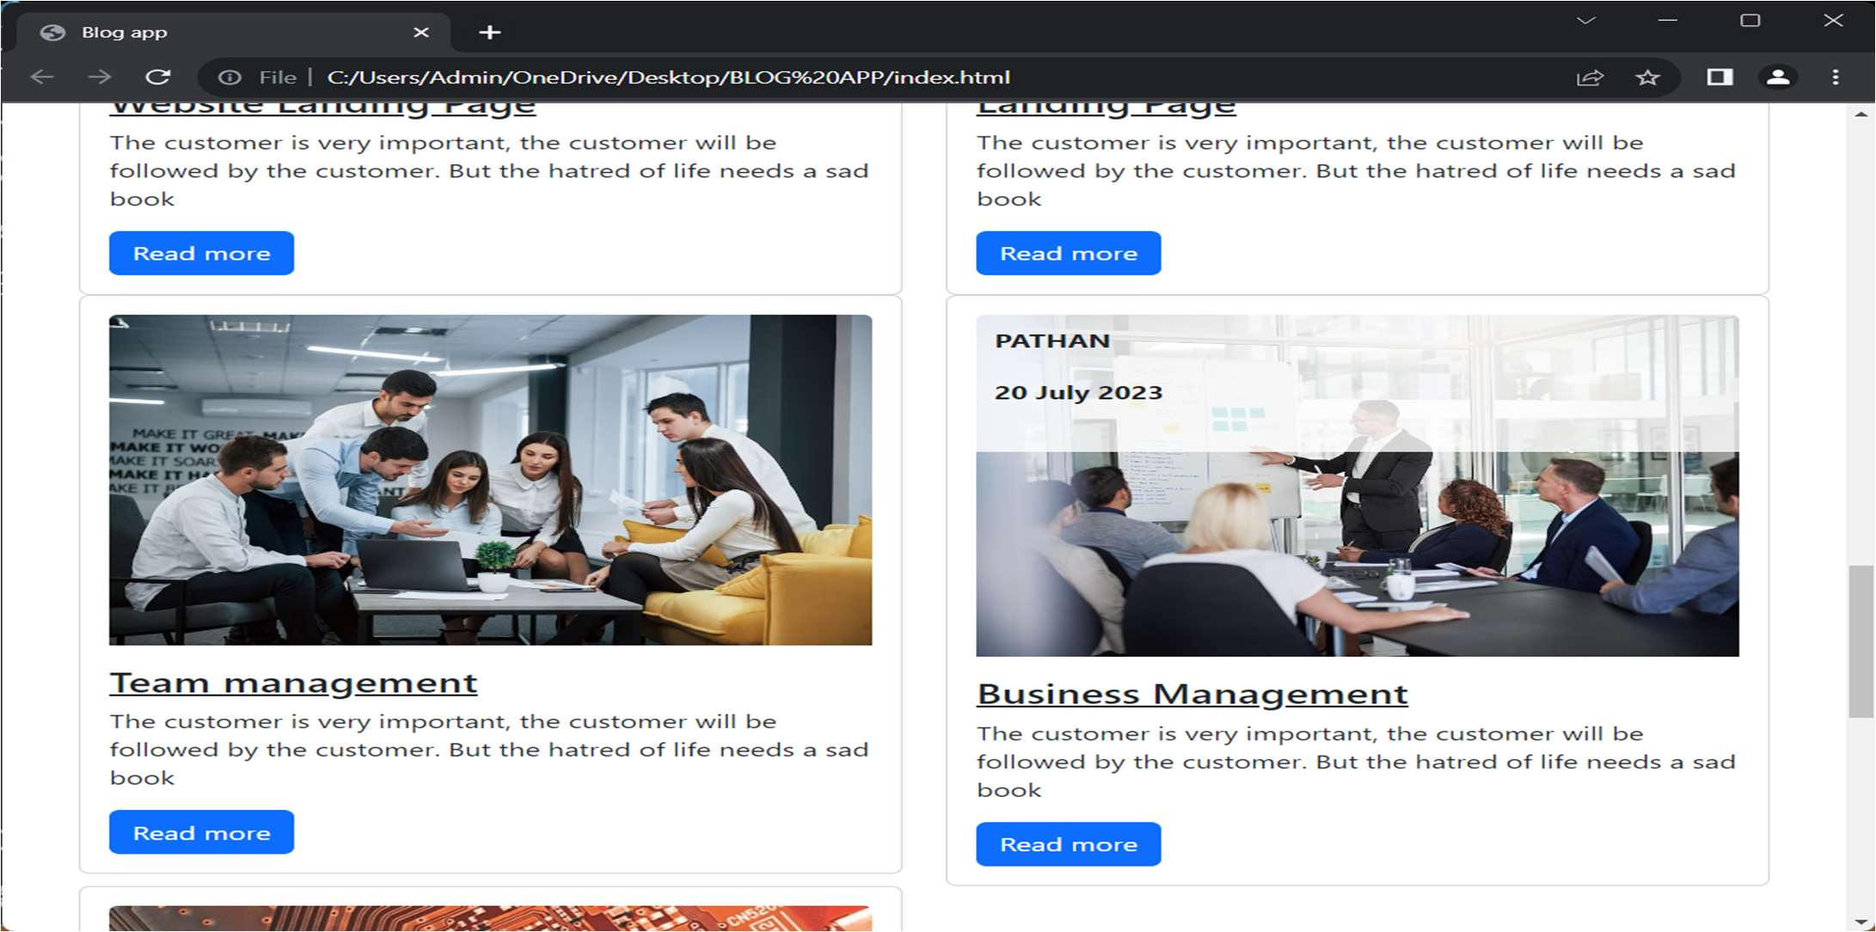

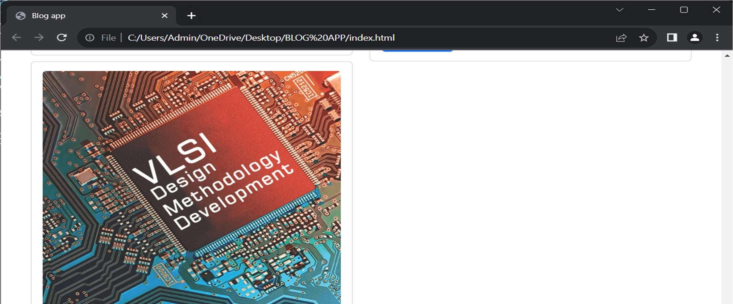

## 5.ADVANTAGES AND DISADVANTAGES

Building a blog app can be a rewarding endeavor, but like any project, it comes with its own set of advantages and disadvantages. Here are some of the main ones:

**Advantages of building a blog app:**

**1.Content Creation and Sharing:** A blog app allows users to create and share their content with a wide audience, which can be beneficial for personal expression, knowledge sharing, and community building.

**2.Personal Branding:** For individuals and businesses, a blog can serve as a platform to establish a strong online presence and develop a personal brand or company image.

**3.SEO Benefits:** Regularly updated blogs can improve a website's search engine optimization (SEO) by providing fresh and relevant content, leading to higher organic traffic and better visibility on search engines.

**4.Engaging User Interaction:** Blogs often come with commenting features, which encourage user engagement, discussion, and feedback, fostering a sense of community around the content.

**Disadvantages of building a blog app:**

**1.Time and Effort:** Developing a blog app from scratch can be time-consuming, especially if you want to implement advanced features and ensure a smooth user experience.

**2.Competition:** The blogosphere is vast and competitive, making it challenging for a new blog app to gain traction and attract a substantial audience.

**3.Content Quality and Consistency:** Maintaining a high-quality blog with valuable content and regular updates can be demanding, requiring consistent effort and dedication.

**4.Security Concerns:** Blogs are susceptible to security vulnerabilities, such as hacking attempts and spam. Ensuring robust security measures is essential to protect user data and maintain the app's integrity.

In summary, building a blog app offers various benefits, such as content creation, personal branding, and SEO advantages, but it also comes with challenges related to competition, content quality, and technical maintenance. Weighing these factors and having a well-defined strategy can increase the chances of success for your blog app properly.

## 6.APPLICATIONS

Building a blog app for front-end web development offers a wide range of benefits, both for developers and end-users. Here are some applications and advantages of building a blog app specifically for frontend web development:

**1.Skill Enhancement:** Creating a blog app can be an excellent project for front-end developers to enhance their HTML, CSS, and JavaScript skills. It allows them to practice responsive design, layout structuring, and creating interactive user interfaces.

**2.Portfolio Project:** A blog app can serve as a showcase for front-end developers to demonstrate their abilities and creativity to potential employers or clients. It acts as a tangible example of their coding capabilities.

**3.Learning Frameworks:**Developing a blog app provides an opportunity to work with popular front-end frameworks like React, Angular, or Vue.js. These frameworks simplify the development process, improve performance, and enable building complex frontend applications.

**4.UI/UX Design:** Building a blog app allows frontend developers to focus on creating an intuitive and visually appealing user interface. They can experiment with different design elements, typography, color schemes, and animations to enhance the user experience.

**5.Responsiveness:** Frontend developers can practice making the blog app responsive across various devices and screen sizes. This ensures that users can access and read the blog posts comfortably on desktops, tablets, and mobile phones.

**6.Performance Optimization:** Optimizing the front-end code for speed and performance is critical. Frontend developers can apply techniques like code splitting, lazy loading, and caching to enhance the app's loading time and overall performance.

In summary, building a blog app for front-end web development offers a valuable learning experience and a chance to showcase skills while creating a practical and engaging user interface. It's a project that provides numerous opportunities for growth and improvement as a frontend developer.

## 

## 7.CONCLUSION

Building a blog app using front-end web development is an enriching and multifaceted endeavor that offers several benefits for developers and end-users alike. It provides a platform for front-end developers to showcase their skills, experiment with cutting-edge technologies, and create an engaging and visually appealing user interface. Here are some key takeaways and conclusions:

**1.Skill Advancement:** Developing a blog app is an excellent way for front-end developers to improve their proficiency in HTML, CSS, and JavaScript. It allows them to refine their UI/UX design skills and explore the capabilities of frontend frameworks.

**2.Continuous Improvement:** A blog app is an ever-evolving project, allowing developers to continually enhance its features, incorporate user feedback, and adapt to emerging trends in front-end web development.

**3.Mobile App Development:** The blog app can act as a steppingstone for front-end developers interested in mobile app development. By leveraging frameworks like React Native or Flutter, they can transform the app into a native mobile application.

**4.User Engagement:** A well-designed and interactive blog app encourages user engagement through comments, social media sharing, and intuitive navigation, fostering a vibrant and connected community.

In conclusion, building a blog app using front-end web development is an invaluable learning experience and a testament to a developer's capabilities. It empowers them to create an impressive user interface, prioritize accessibility and performance, and explore the dynamic world of frontend technologies. Whether as a personal project or a professional undertaking, developing a blog app serves as a steppingstone for front-end developers to thrive and make a meaningful impact in the digital landscape.

## 

8.FUTURE SCOPE

The future scope for building a blog app using front-end web development remains promising, as the digital landscape and user expectations continue to evolve. Here are some potential future directions and opportunities:

**1.Progressive Web Apps (PWAs):** PWAs are web applications that provide a native applike experience on the web. They offer features like offline access, push notifications, and improved performance. Building a blog app as a PWA can enhance user engagement and provide a seamless experience across different devices and network conditions.

**2.Voice User Interface (VUI)**: With the growing popularity of voice assistants and smart speakers, integrating voice user interfaces into the blog app can open new interaction possibilities. Frontend developers can explore technologies like Web Speech API to enable voice-based navigation and content consumption.

**3.Augmented Reality (AR) and Virtual Reality (VR):** As AR and VR technologies

advance, incorporating immersive experiences into the blog app can set it apart from traditional platforms. Visualizing content in 3D, creating interactive AR blog posts, or building a VR-based reading environment are potential areas to explore.

**4.Advanced Animation and Microinteractions:** Leveraging advanced animation techniques and microinteractions can create a more engaging and delightful user experience. Frontend developers can focus on fluid animations, subtle transitions, and interactive elements to capture users' attention and retain their interest.

**5.Blockchain Integration:** Integrating blockchain technology can enhance the security and transparency of the blog app. For instance, blockchain-based authentication systems or content verification mechanisms can be explored.

In conclusion, building a blog app for frontend web development holds a promising future, with numerous opportunities to embrace emerging technologies, enhance user experiences, and adapt to changing user needs. By staying proactive, keeping up with technological advancements, and prioritizing user-centric design, frontend developers can ensure that their blog app remains relevant and competitive in the dynamic digital landscape.

THANK YOU